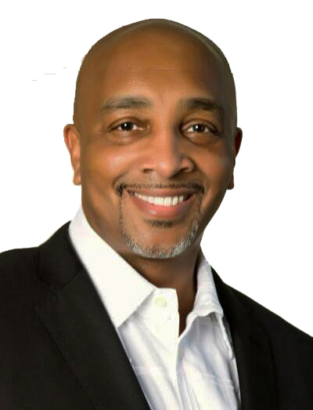
Dr. D. Ivan Young Bio

Dr. D. Ivan Young (AKA “Dr. D”), CPDC is a highly acclaimed TEDx Speaker and Master credentialed expert on personality type. He is recognized as one of the most notable Life Coaches in the United States because of his provocative teaching style on complex relationship subjects.

In December of 2016, the City of Houston and The Houston City Council recognized Dr. Young for his influence in the national media and his life-changing impact on both family and institutional relationships, both locally and nationally. He was named Life Coach of The Year by The National Black Life Coach’s Network in 2017 and in 2018, awarded Lifetime Achievement Awards for his positive impact on American Culture by the United States Congress and The Texas State Senate. He has been awarded The President's Lifetime Achievement Award by two White House Administrations for his many contributions as an inspirational thought leader.

He is a credentialed Master MBTI Practitioner, Master Coach and Master Neuro-Linguistic Programming Practitioner with a PhD in Holistic Life Coaching, and a Certified Professional Diversity Coach (CPDC) through Coach Diversity Institute. Dr. D was awarded the Vice Chancellors Award from the University of Houston and currently serves as an executive advisory board member for the Black Life Coach Association. He has been featured in/on CNN, MSNBC, 20/20, The Huffington Post, Black Enterprise, Essence Magazine.Com, Yahoo News, FOX News, ABC, NBC, CBS Radio, iHeartRadio, Access Hollywood, FOX News Magazine, and TEDx. He has been featured on TV One's Hit Programs Fatal Attraction & Justice by Any Means, and the Oxygen Network’s hit program Snapped - Killer Couples. His most recent book, Another Chance...Where Would You Be Without One? became an Amazon Best Seller in the fall of 2015. His published work, Break Up, Don't Break Down was released by Reality -N- 3D Publishing in April, 2010 and coined The Relationship Manual by the Associated Press.

Today Dr. D. Ivan Young is working on a new book centered on the current status of America, politics and a divided nation. He is touring the United States on public speaking engagements and spends time mentoring youth programs in Houston.

